14.28: The rock displaces a volume of water whose weight is 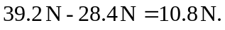 The mass of this much water is thus 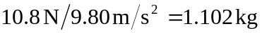and its volume, equal to the rock’s volume, is
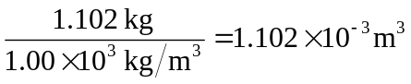

The weight of unknown liquid displaced is 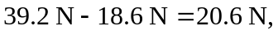and its mass is 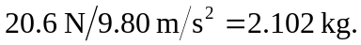 The liquid’s density is thus 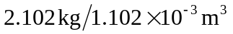 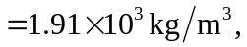or roughly twice the density of water.

